Arts Queensland budget completion guide

This guide is intended to assist applicants with completing their budget for Arts Queensland (AQ) funding programs through the online grant system SmartyGrants.

Before you start, for general advice on budget development and preparation, download the Arts Acumen Budget Preparation Toolkit.

TIP: When navigating the application always use the form navigation list. Click on the topic of the page you wish to go to.
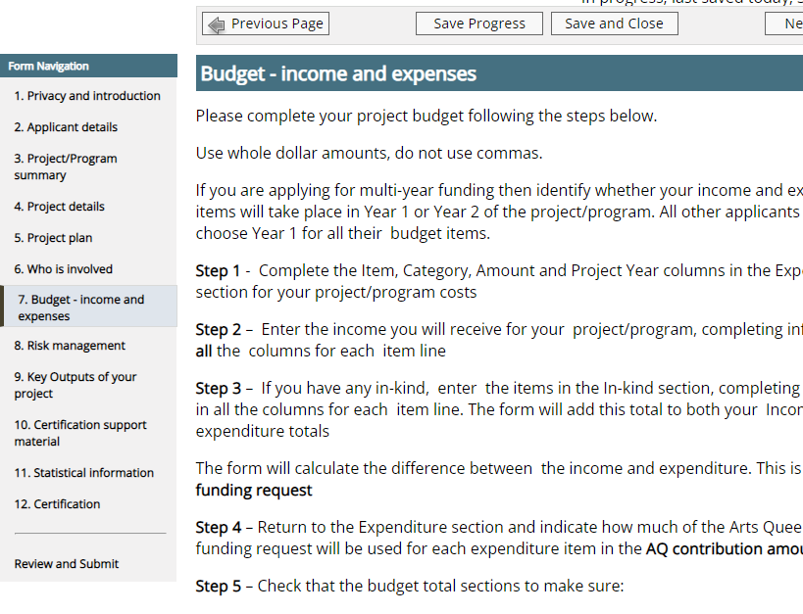
Warning: Do not use browser arrows to navigate between application pages because you will lose information you have added to the form even if saved.
Remember to always Save Progress at top or bottom of the page, at a minimum after each of the following steps.

Overview of completing the budget

Step 1 - Complete the Item, Category, Amount and Project Year columns in the Expenditure section for your project/program costs. Use whole dollar amounts, do not use commas.

Step 2 – Enter the cash income you will receive for your project/program, completing information in all the columns for each item line. Please note: Do not include In-kind expenses in the expenditure section of the budget.

Step 3 – If you have any in-kind, enter the items in the In-kind section, completing information in all the columns for each item line. The form will add this total to both your Income and expenditure totals and will calculate the difference between these two totals. This is the figure for AQ funding request.

Step 4 – Return to the expenditure section and indicate how much of the Arts Queensland funding request will be used for each expenditure item in the AQ contribution column.

Step 5 – Check budget total sections to make sure:
- You have allocated the exact amount of AQ funding request across eligible items of expenditure
- You have not requested more than the allowed percentage of funding
- You have completed notes in the budget section.

Step 1 – Expenditure

In this section, you need to list all the expenses you require to deliver your project/program. Remember, when filling in amounts, do not use $ sign or commas. The system will automatically put these in for you when you click Save Progress.

Enter the expenses or costs required to do your project items on separate lines. Choose the category from the list that best suits the type of expenditure in your item description. More detail about what the categories mean can be found in the General Guidelines under Glossary.
This column can be filled out at Step 4
If applying for multi-year funding complete year of expenditure. All other applicants should choose Year 1 for all their budget items.

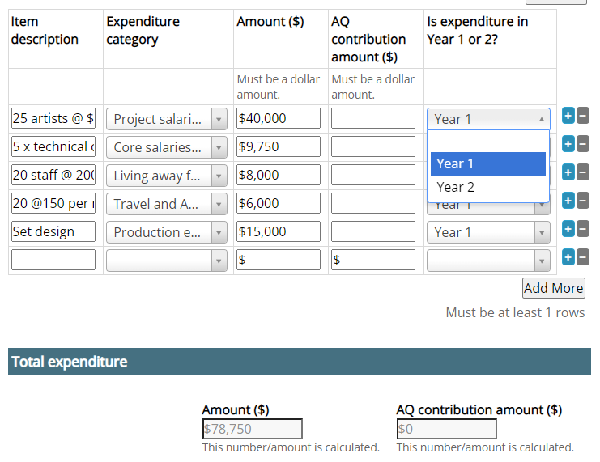
Choose most appropriate descriptions, definitions here.
Give sufficient information in the Item Description so that the assessors can see:
- how the Amount has been calculated e.g., hire at $50 dollars a week for 6 weeks, or 100 items at $200 each.
- how many people involved and the nature of their work and the length of their engagement.
Click on the + button to add more budget lines.
If you are not GST registered: amounts should include GST as this is part of the cost of the project.
If you are GST registered: Arts Queensland will pay the funds plus GST; amounts should therefore be exclusive of GST.

If you are not GST registered: amounts should include GST as this is part of the cost of the project.
If you are GST registered: Arts Queensland will pay the funds plus GST; amounts should therefore be exclusive of GST.

If you have expense items that are in-kind, please DO NOT include in the expenditure section of the budget.

Step 2 – Income

In this section list all income sources for cash only and identify if they are confirmed or unconfirmed.

Please be specific in the Item description about the name of the organisation, agency, or other source.

Always select the Year 1 or 2 depending on whether applying for one-year or multi-year funding.
There is a selection of income categories to choose, definitions here.

Example
Select whether funding is confirmed or unconfirmed
Make sure whole dollar numbers only
Clearly describe item, add notes to budget if requires explanation
Always put year. If project lasts less than a year choose Year 1.
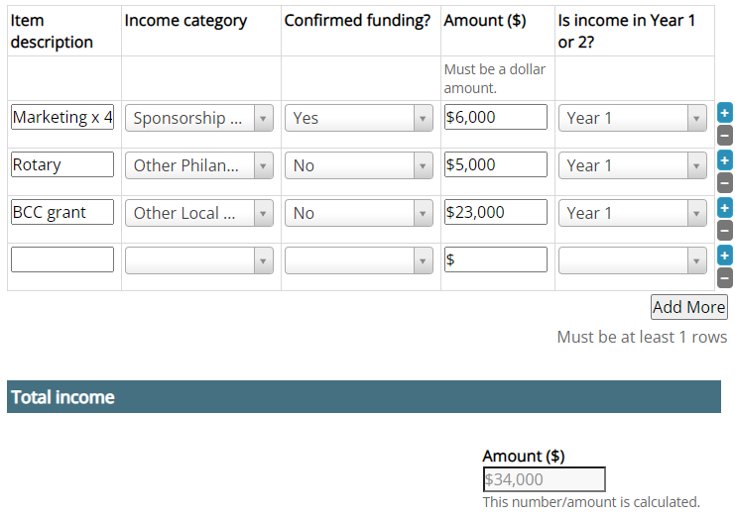
Remember to always Save Progress at top or bottom of the page.
Step 3 – In-kind

In this section list all In-kind support, which can include real project costs provided free of charge such as volunteer labour, administrative support, rent-free accommodation or donations of materials or equipment.

In-kind income refers to the dollar value of any goods and services you receive but do not pay for. For example, free or discounted equipment, materials, venue space, professional services (e.g. legal, financial) and the labour of volunteers.
The form will add this total to both your Income and expenditure totals.
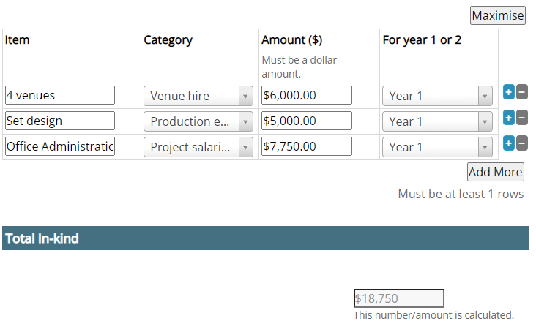
Enter the items in the In-kind section, completing information in all the columns for each item line.
Remember to always Save Progress at top or bottom of the page.

Step 4 – Check budget

Review Totals section at end of budget to see the difference between expenditure and income. The form will calculate the difference between these two fields, and this should be your AQ funding request.

In the example below total expenditure is $97,500 and total income of $52,750 with a $44,750 difference between them, this your AQ funding request.

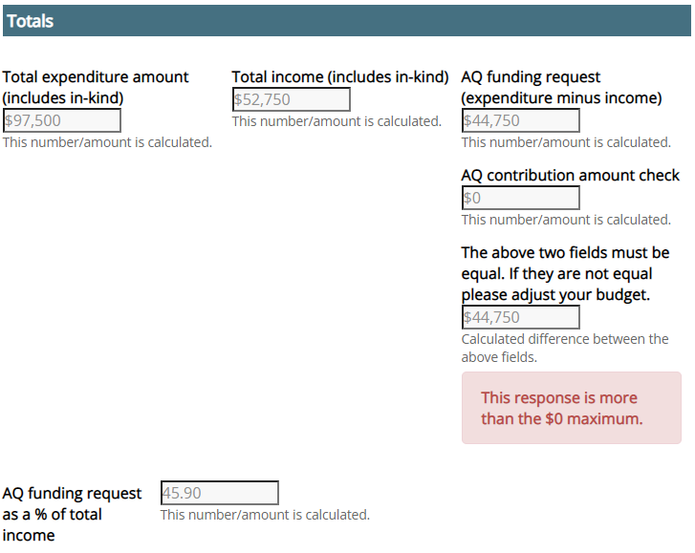
Red text box indicates there is an error in the budget
Currently shows that $44,750 is the difference between expenditure and income because there is nothing in AQ contribution amount check. You will need to complete expenditure section and add to AQ contribution amount to the value of $44,750.
Now you know how much AQ funding is needed for your activity (in this example $44,750) you can complete the AQ Contribution amount ($) and show how the AQ funding will be used against expenditure items listed in your budget.
Go back to expenditure section and complete costs in the AQ contribution amount column.

Remember to always Save Progress at top or bottom of the page.

Step 4 – continued
Go the expenditure section at beginning of the budget and complete AQ Contribution amount ($) for combined total value of difference between expenditure and income.
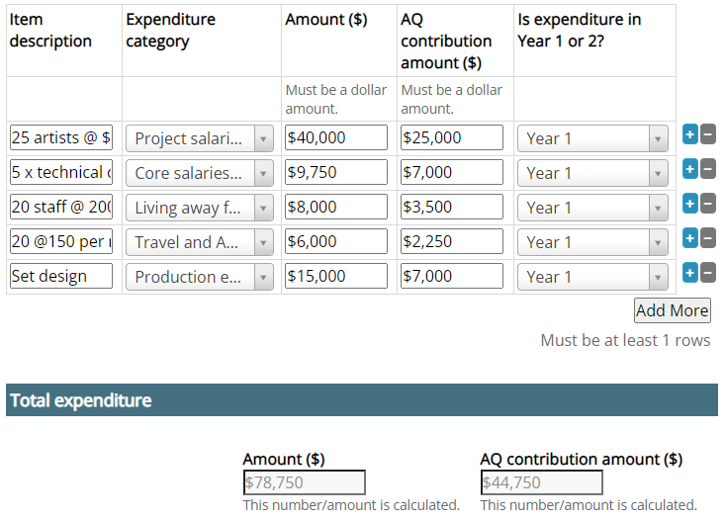
This amount shows the total of AQ funding you have allocated against items in AQ contribution amount column. It should match the total AQ funding request at the end of the budget.
Ensure AQ contribution amount is not more than in the Amount ($) column
Check AQ funding request and AQ contribution amount are the same at Totals section at end of of budget.
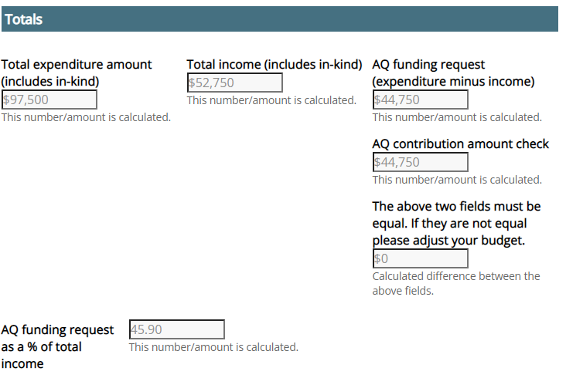
This box will be $0 if you have allocated the full AQ funding request. If this number is more than zero you have allocated more funding than you need, if it’s a minus number you haven’t allocated enough.
Step 5 – Notes to budget

This section gives you a chance to put in any explanatory notes for income/expenditure items that will assist the peers when assessing your application. Please outline any information that will assist to clarify or justify the costs calculated in your budget. For any unconfirmed income please include the name of the funding program and notification date of any funding you have applied for and included in your budget.

For example: for your artist fees, instead of listing out each individual artist in the expenditure section, you can put artist fees as a total cost and then list the details of the artist fees in the notes to budget text box.

Budget tips:
Budget information should be realistic, and we recommend you provide current quotes for significant expenditure items in the supporting materials at the end of this section.

Review
Now that you have completed your budget it’s time to review before moving on to the next section of the application.

Check that the budget total sections:
- you have allocated the exact amount of AQ funding request across eligible items of expenditure
- You have not requested more than the allowed percentage of funding.

Remember to always press the Save Progress button at top or bottom of the page.

Troubleshooting

The form will calculate the difference between the income and expenditure. The amount must be a positive number, which means your income must be less than your expenditure and the difference is the AQ funding request.

Example 1 - incorrect budget, the expenditure and income are the same figure and therefore indicates that you don’t need any AQ funding because you have enough income to cover all your expenses.

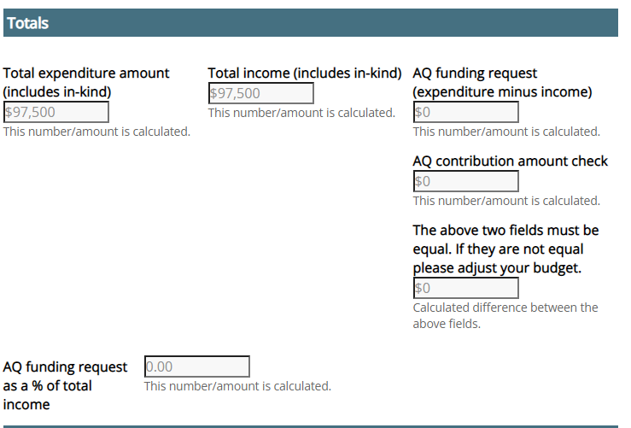

Example 2 - incorrect budget, the income is greater than the expenditure therefore the AQ funding request shows as a negative number, indicating you have more income than you need to spend and do not need AQ funding.

