Regional Arts Services Network
Visual content | Audio content
Rebecca Atkinson | Hi, my name’s Rebecca Atkinson I’m from Arts Queensland. We’re pleased to announce a new and innovative approach to regional arts that empowers local communities to deliver local arts and cultural experiences.
Slide 1:  Arts Queensland consulted widely on an appropriate regional arts model to deliver on the 2017-18 Budget commitment of $6.5 million over four years towards Indigenous and regional arts initiatives.  The Regional Arts Services Network responds to state-wide feedback prioritising:  - Empowering of regional communities through self-determination  - Capacity building to support local arts priorities and projects  - Networking and collaboration across towns and between artists and organisations  - Audience development and increased access to touring product  - Social inclusion, community building and well-being  - Stronger advocacy and promotion of the public value of arts and culture. | The Queensland Government is investing additional funding of $6.5 million over four years to establish a Regional Arts Services Network.  This network will provide a coordinated approach to state-wide regional arts delivery that is responsive to local arts priorities.  Arts Queensland is now calling on service providers to submit their Expressions of Interest in delivering regional arts activities across the State.
Rebecca Atkinson | We are encouraging companies across Queensland to consider how the regions can best take advantage of this opportunity.  Acknowledging the challenges of a state as decentralised as Queensland, the Expressions of Interest process puts collaboration and leadership at the heart of regional arts development.
SLIDE 2  DESIGNATED REGIONS  - Far North Queensland  - North Queensland  - Central Queensland  - South West Queensland  - South East Queensland (north)*  - South East Queensland (south)  * Excludes Brisbane  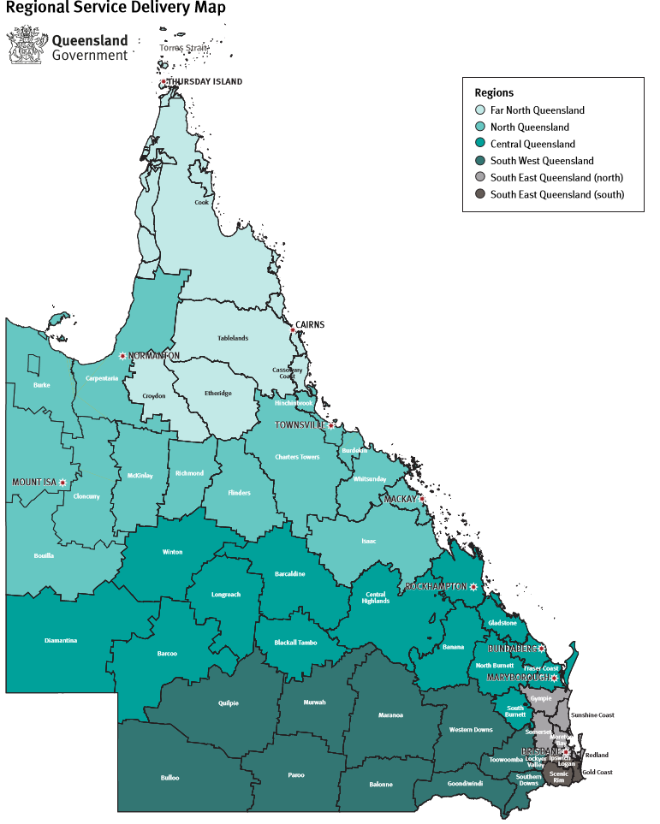 | The six designated regions have been determined upon consideration of state wide service delivery across other Queensland Government departments.
SLIDE 3  REGIONAL ARTS SERVICES NETWORK (RASN)  Regional Arts Services  - MUST employ a dedicated Regional Arts Officer (based in the region)  - Empower the regions in determining local priorities  - Facilitate and deliver community arts and cultural development programs  - Build sector capacity and foster a strong community of arts  - Increase QLD’s success rates in securing arts funding  - Facilitate new employment and training opportunities  - Increase opportunities for Aboriginal and Torres Strait Island artists and communities  State Coordination Office  - Provide a secretariat function for the RASN  - Build sector capacity and foster a strong community of arts  - Broker new partnerships and secure new regional arts investment  - Increase QLD’s success rates in securing arts funding  - Represent the network in state and national contexts  - Increase opportunities for Aboriginal and Torres Strait Island artists and communities  - Secure insurance cover for Local Arts Councils | The Regional Arts Services Network comprises two components – seeking Queensland providers that will deliver Regional Arts Services across six designated regions, and a State Coordination Office.  Providers delivering Regional Arts Services must include the employment of a locally-based arts officer. One officer in each of the six designated regions.  The second component is a State Coordination Office service.  This service will provide a secretariat function to the Regional Arts Service providers and facilitate a coordinated approach to regional arts activities across the State.  It will also support capacity building of regional artists and arts organisations, foster cultural leadership and assist with networking and partnerships.  The State Coordination Office will also be a contact point for local arts councils.
Rebecca Atkinson | To support new projects generated through the Regional Arts Services Network, a new funding stream will be established within our existing Queensland Arts Showcase Program.
SLIDE 4  REGIONAL ARTS FUNDING  Support for the Regional Arts Services Network Activities  A new contestable funding stream will be established to support regional activity generated by the Regional Arts Services Network.  Companies awarded Agreements to deliver Regional Arts Services and/or the State Coordination Office will be eligible to apply to this new funding stream to support delivery of services in partnership with local artists and stakeholders.  Further details will be released in mid-2018. | This funding aims to incentivise regional projects that demonstrate the power of the arts to enrich the lives of individuals, build sector capacity, promote local stories and make positive changes in communities.  More information in relation to the new QASP funding stream will be available later in the year.  We will now provide a short summary of some of the important points about the Expression of Interest process.
SLIDE 5  PROCUREMENT  Arts Queensland is seeking to procure the services of suitably qualified and experienced companies to deliver the Key Deliverables for Regional Arts Services and the State Coordination Office.  Procurement involves the purchase of specific services to assist the Government in achieving its priorities.  Two-Stage Process (eligible offerors may tender for both opportunities)  - Stage One: Submission of expressions of interest  - Stage Two: Direct negotiation (invitation only)  Check Eligibility, Key Deliverables and Evaluation Criteria in the EOI – Information for Providers. | Working within the Queensland Government’s Procurement Strategy and Policy framework, Arts Queensland is seeking to award Service Agreements to deliver the Key Deliverables of the two different services areas, Regional Arts Services and a State Coordination Office, over a four year contract term.  It is important to acknowledge that the Regional Arts Services Network Expression of Interest is a procurement process, not a grant process.  Arts Queensland is committed to integrity, transparency and fairness and has engaged an independent probity advisor to oversee the two-stage procurement process.  The two stages of this procurement process are a submission of an expression of interest as the first stage. With shortlisted companies invited to a second stage of negotiation.  To assist all parties with their submission there are three opportunities during the Expression of Interest process to submit questions.  I’ll now hand over to Iain McIndoe from O’Connor Marsden to speak to the probity elements of this procurement process.
Iain McIndoe | Thanks Rebecca. Hi I’m Iain McIndoe from O’Connor Marsden, we are probity advisors to Arts Queensland for this process.  What’s external probity?
Slide 6  PROBITY  Probity Objectives  - Accountability and transparency  - Fairness and impartiality  - Security and confidentiality  - Identification and resolution of conflicts of interest. | That’s all about fairness and transparency and running a fair process. It’s important to the Queensland Government and to Arts Queensland which is why they’ve engaged us, but it’s more about you responding to the EOI then it is about them.
Slide 7  PROBITY  Probity Advisor  - O’Connor Marsden has been engaged as an external probity auditor to support the EOI process.  Iain McIndoe  Principal  OCM  Level 24, AMP Place, 10 Eagle Street  Brisbane, QLD 4000  Tel: 1300 882 633  Email: Imcindoe@ocm.net.au  Mobile: +64 409 347 150  http://www.ocm.net.au | I’m your contact if you have probity issues, or queries about the process that you didn’t initially want to raise with Arts Queensland.
Iain McIndoe | The sorts of things that you might have queries about particularly, could be managing conflicts of interest, could be because you’re new to government procurement processes, which can be complicated.  It could be about managing confidential information, which you’ve acquired for another purpose but you want to use here. And most likely it could be to do with managing other relationships, what we call business as usual relationships with Arts Queensland, while this tender process is happening.  So the thing to take away from me, is that I’m the point of contact for all those questions in the first instance. My contact details are on the website, so please feel free to come to me if you have queries.  The last thought is don’t leave a question unasked. If you have a question, please ask it. Don’t leave it till the end and wish you’d asked.  Thankyou.
Rebecca Atkinson | Thank you Iain, I’ll now talk through further detail of the Expression of Interest requirements.
SLIDE 8  MANDATORY REQUIREMENTS  Regional Arts Services  Providers must be based in regional or remote Queensland to be eligible to submit an EOI to deliver Regional Arts Services functions  Regional Arts Services providers must employ a dedicated Regional Arts Officer in each of the designated regions serviced  State Coordination Office  Providers must be based in Queensland | Expressions of Interest will be accepted from legally-constituted companies – or partners working together in a consortium.  Local councils cannot independently apply, but they can be part of a consortia.  To be eligible, providers submitting an Expression of Interest to deliver Regional Arts Services must be based in regional Queensland.  Organisations wishing to deliver State Coordination Office services must be based in Queensland.  Eligible providers may tender for both opportunities, the regional arts services and the state coordination office.
SLIDE 9  EVALUATION CRITERIA  Capability (40%)  Capacity, networks, experience, strategies, opportunities for Aboriginal and Torres Strait Islander communities  Viability (35%)  Methodology, budget, best practice governance and management  Stakeholder Management (25%)  Track record, working collaboratively, experience with complex governance structures | An evaluation panel of key stakeholder representatives and Arts Queensland will assess each Expression of Interest against the Evaluation Criteria of Capability, Viability and Stakeholder Management.  Interested parties are reminded that the Expression of Interest is a procurement, rather than a grant process. There is a significant difference between these two processes and this needs to be considered when preparing your submission.
Rebecca Atkinson | In summary, a procurement involves the purchase of specific services to assist the Government in achieving its priorities.  There is reciprocal value and benefits derived from delivering the contract, for Government and the service providers. A grant is a contribution made towards your own project.  Other criteria for parties wishing to make a submission are available on the Arts Queensland website.
SLIDE 10  GENERAL ENQUIRIES  All EOI enquiries will be responded to through the clarification question process and must be emailed to regionalartsservices@arts.qld.gov.au  There are three deadlines to submit clarification questions (see Timeline)  The final deadline for receipt of clarification questions is 20 February 2018  Final responses will be published online by 23 February 2018 | In support of Arts Queensland’s commitment to transparency and integrity, all enquiries relating to the Expression of Interest process must be emailed to regionalartsservices@arts.qld.gov.au.
SLIDE 11  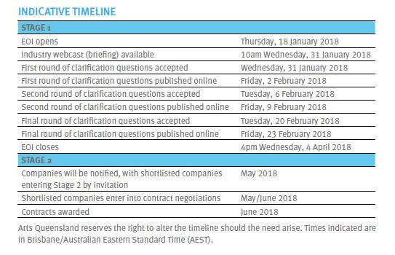 | There are three deadlines to submit clarification questions as detailed in the Timeline table of the Information for Providers document.  This is available on our Arts Queensland’s website.  There is also a list of Frequently Asked Questions.
Rebecca Atkinson | The Regional Arts Services Network is an exciting opportunity for regional and Indigenous arts and for our local communities.  We encourage all arts groups in regional Queensland to view this information and take action to find out how the network can assist arts projects in their local communities.  Arts Queensland has information available on our website to assist interested parties. You can also contact us by email.  Thank you very much for your interest in working with Arts Queensland on this new model of regional arts delivery.

