Indigenous Art Centre Launch Fund

Guidelines

Introduction

The arts and cultural sector has been significantly impacted by the COVID-19 pandemic and associated restrictions with artists and arts workers facing additional challenges in the current environment. In June 2020, the Queensland Government announced an Arts and Culture Recovery Package of $22.5 million over two years to stabilise Queensland’s arts companies, secure employment for artists and arts workers and deliver COVID-safe cultural experiences for Queensland audiences.

In addition to this investment Arts Queensland, in consultation with the sector, has refocussed existing grant programs to further strengthen sector activity and provide economic opportunity, employment and audience engagement during the recovery phase.
Arts Queensland acknowledges that Aboriginal and Torres Strait Islander communities have faced additional challenges during the COVID-19 pandemic, due to higher risks to health issues and additional restrictions on remote Indigenous community access.

First Nations visual artists and arts workers have been significantly impacted by the COVID-19 pandemic and associated movement restrictions. The Queensland Government recognises the need to support Indigenous Art Centres across the state to generate economic and employment opportunities for artists and arts workers, and to further celebrate Aboriginal and Torres Strait Islander arts and culture in Queensland.

Arts Queensland is a proud supporter of Indigenous artistic and cultural expression through the Queensland Government’s Backing Indigenous Arts (BIA) initiative, which aims to build sustainable and ethical Aboriginal and Torres Strait Islander arts industries. The BIA initiative objectives are:
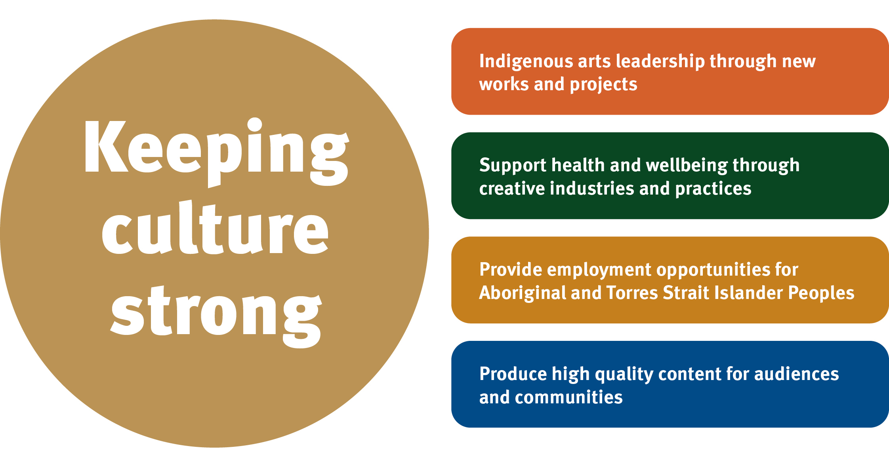

What is the Indigenous Art Centre Launch Fund?

The Indigenous Art Centre Launch Fund is a new two-year funding program available to Queensland based established Indigenous Art Centres that are already engaged in supporting First Nations artists and arts workers in professional visual arts practice, and are not currently funded through Queensland Government’s Backing Indigenous Arts (BIA) initiative.

The fund aims to:
- support Aboriginal and Torres Strait Islander artists and arts workers during COVID-19 recovery
- support sustained operations of IACs that are new to the BIA funded IAC network
- strengthen and enrich the IAC network in Queensland

The funding builds on Queensland Government’s existing support delivered through the BIA Indigenous Art Centre (IAC) Multi-Year (2019-2023) funding.

What can you apply for?

Indigenous Art Centres can apply for two-year funding (2020-21 and 2021-22) of up to $60,000 per annum to support:
- operational costs for the delivery of arts and cultural services and activities
- professional services costs related to governance, management and promotion of programs and products
- initiatives that generate economic opportunities for Aboriginal and Torres Strait Islander artists and artsworkers.

The Indigenous Art Centre Launch Fund is limited to the funding period (over two financial years).

Your organisation may also consider applying for project funding through the First Nations Commissioning Fund. Information for this fund can be found here www.arts.qld.gov.au/aq-funding/first-nations-commissioning-fund.

Who can apply?

The Indigenous Art Centre Launch Fund is for Indigenous Art Centres that:
- are based in Queensland with the core business objective of maintaining and supporting First Nations visual arts and cultures, and providing leadership and employment opportunities for Aboriginal and Torres Strait Islander peoples
- demonstrate strong governance structures led by Aboriginal and Torres Strait Islander members
- demonstrate community support, and have an active community of Indigenous artists
- have an active strategic and/or business plan in place.

To be eligible, your organisation must:
- not be a current recipient of BIA IAC multi-year (2019-2023) funding
- have satisfied the reporting requirements of any previous Arts Queensland funding
- have an active Queensland-registered Australian Business Number (ABN)
- be one of the following entity types:
  - an Aboriginal and/or Torres Strait Islander Corporation registered under the Corporations (Aboriginal and Torres Strait Islander) Act 2006
  - an Indigenous organisation established through specific Commonwealth or State or Territory legislation
  - an Indigenous incorporated association
  - an Indigenous not-for-profit organisation
  - an Indigenous local government body
- have attached all relevant support material to the application form
- not seek 100% of the organisation’s costs from Arts Queensland

How to apply

The Indigenous Art Centre Launch Fund will open for applications 20 July 2020 and close 20 August 2020.

Applicants will be informed of their application results in late September 2020.

To apply online, visit the following web link to access the application form, and submit your application by 12 noon on 20 August 2020: https://artsqueensland.smartygrants.com.au/applicant/login?returnUrl=/.

We will send you an email to let you know that the application has been received.

What to attach

Your application form must contain all compulsory support material. Support material is important to provide evidence of the information and claims in your application.

To be eligible, your application must contain the following required support material:
- Financial information – audited financial statements for previous 2 years, cash flow forecast for 2020-21
- Strategic plan or Business plan
- Program outline for funding years (or detailed plan of activities)
- Letters of support from local community including artists, council/s and businesses support/partnerships

How will my application be assessed?

Applications will be assessed by the First Nations Arts and Culture Panel, who will make funding recommendations to the Minister for the Arts or delegate, against the following criteria:

Quality
- Demonstrated expertise to deliver the organisation’s objectives
- Recognised as providing high-quality artistic and cultural products and services

Reach
- Evidence of community engagement informing program and services
- Demonstrated demand for the centre’s programs and services

Impact
- Evidence of partnerships with arts and non-arts entities (financial and in kind)
- Capacity to provide ongoing career opportunities for Aboriginal and Torres Strait Islander artists and arts workers

Viability
- Strong governance and management of the centre and its resources
- Capacity to leverage investment from other sources

If you need help

You can find information about the Indigenous Art Centre Launch Fund including Frequently Asked Questions, Information for Applicants, and other information www.arts.qld.gov.au/aq-funding/indigenous-art-centre-launch-fund.

Contact us:

Phone Brisbane (07) 3034 4016
Phone Cairns: (07) 4047 4910
Toll free: 1800 175 531
Email: bulmba-ja@arts.qld.gov.au
Website: www.arts.qld.gov.au

Explore Arts Acumen:

There is more information about writing applications, preparing a budget on the Arts Queensland website: http://www.arts.qld.gov.au/arts-acumen/resources/funding-application-writing.

