Backing Indigenous Arts

First Nations Commissioning Fund

Guidelines

Introduction

The arts and cultural sector has been significantly impacted by the COVID-19 pandemic and associated restrictions with artists and arts workers facing additional challenges in the current environment. In June 2020, the Queensland Government announced an Arts and Culture Recovery Package of $22.5 million over two years to stabilise Queensland’s arts companies, secure employment for artists and arts workers and deliver COVID-safe cultural experiences for Queensland audiences.

In addition to this investment Arts Queensland, in consultation with the sector, has refocussed existing grant programs to further strengthen sector activity and provide economic opportunity, employment and audience engagement during the recovery phase.
Arts Queensland acknowledges that Aboriginal and Torres Strait Islander communities have faced additional challenges during the COVID-19 pandemic, due to higher risks to health issues and additional restrictions on remote Indigenous community access.

The contribution of First Nations Peoples to the arts and cultural economy of Queensland is significant. The strength and growth of the sector relies on the sustained practices of Aboriginal and Torres Strait Islander artists, arts workers and organisations.

The Queensland Government’s Backing Indigenous Arts (BIA) initiative supports sustainable and ethical arts industries in Queensland.

BIA objectives are

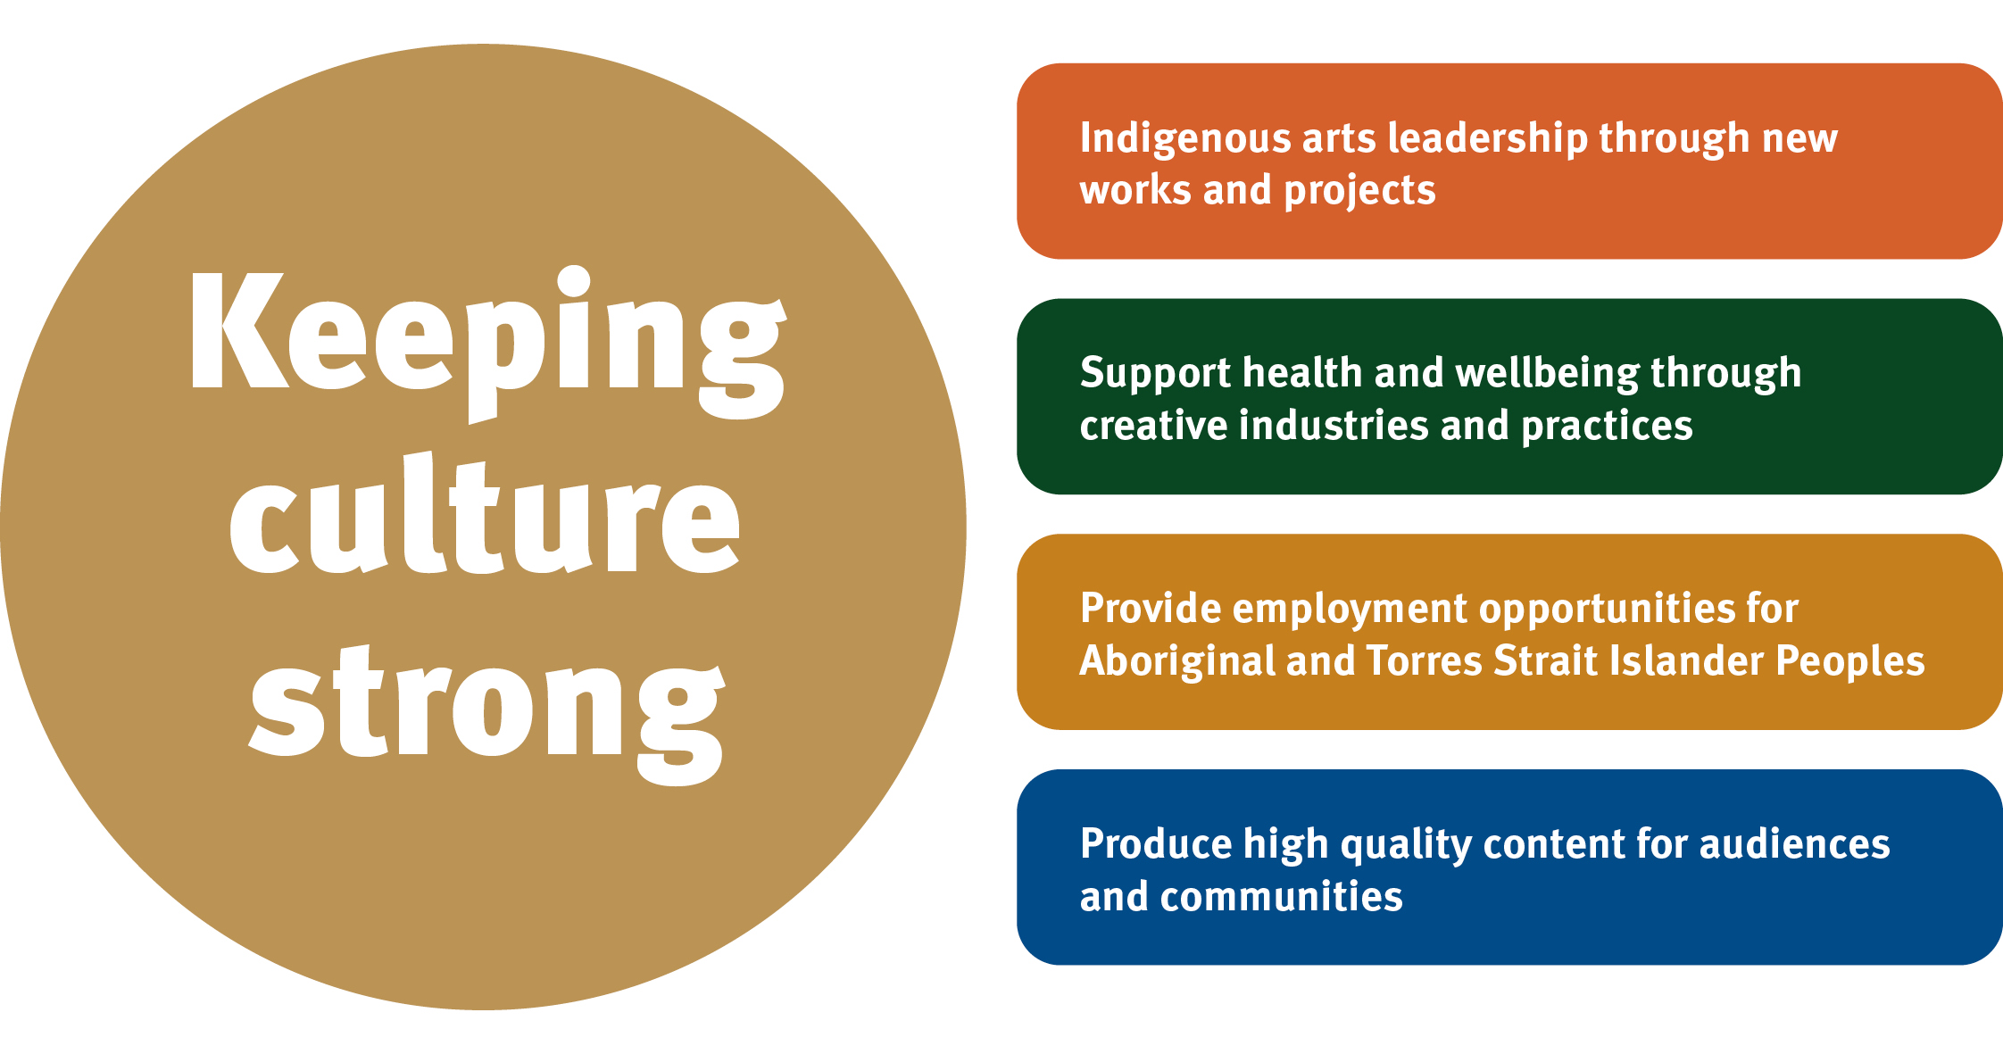

What is the First Nations Commissioning Fund?

The First Nations Commissioning Fund is for Aboriginal and/or Torres Strait Islander arts and cultural practitioners, organisations, collectives or communities to commission and deliver uniquely Queensland Indigenous stories, arts and cultural experiences, products and celebrations.

This fund is not intended to support the business activities of commercial arts businesses whose core business is the purchase and sale of art. Rather, it is intended for the development of new work that will have a life through public display, presentation or sale by not-for-profit entities.

How much you can apply for?

Under this fund, if you are eligible, you can make application for:
- up to $100,000 towards large scale commissions. This may include large scale creative projects, development, festivals or presentations and must involve other partners and collaborators. Projects can take place at multiple venues or in communities across Queensland. Applicants cannot apply for 100% of project costs through this funding stream.
- up to $30,000 towards small scale commissions. Applicants can apply for 100% of project costs through this funding stream.

Who can apply?

To apply you must be an Aboriginal and/or Torres Strait Islander artist/arts worker, organisation or collective based in Queensland, which:
- has an active Australian Business Number (ABN) in the same name as the application
- can provide appropriate cultural permissions relevant to the application
- can show the work directly benefits Indigenous artists and/or communities
- can demonstrate that funding received will be directed primarily to First Nations Peoples and/or communities involved
- has satisfied the reporting requirements of any previous Arts Queensland funding
- can present the work within one year of funding approval
- will not commence funded activities prior to 25 September 2020
- has only submitted one application to this round of the First Nations Commissioning Fund
- is not seeking 100% of project costs through the large-scale commission stream.

Arts Queensland also accepts applications to the First Nations Commissioning Fund made on your behalf by an auspice organisation. An auspicing body must:
- have an active ABN
- have a bank account in the name of the auspicing body
- agree to support an individual, organisation or group who is unable to make an application on their own behalf and manage any approved grant (further details below)
- agree to support an individual, organisation or group that meets the objectives of the auspicing bodies constitution
- submit the application in the name of the applicant (individual, organisation or group)
- be a small to medium arts/cultural organisation previously funded by Arts Queensland since 1 January 2019.
- must not submit another application to the First Nations Commissioning Fund for the same project.

The following are ineligible for funding support:
- Current Arts Queensland employees or former employees who ceased employment less than six months before applying. Employees of Arts Statutory Bodies and the Department of Environment and Science should consult the ‘Important Information for Applicants’ document before applying.
- Applicants receiving investment through Arts Queensland’s Organisation Fund who are unable to demonstrate how the project differs from core business activities.

What can you apply for?

You can apply for funding to contribute to the commissioning, development and presentation of new First Nations works by Aboriginal and Torres Strait Islander Peoples, organisations, collectives or communities.

Funded activity may include:
- commissioning of high-quality visual arts, mixed media or performance works by Aboriginal and Torres Strait Islander artists and organisations
- creative development of emerging Indigenous works
- professional fees for key First Nations creatives including cultural consultants, writers, designers, artists, directors, choreographers, dramaturgs, performers and other lead artists and arts workers
- Aboriginal and Torres Strait Islander emerging festivals or events in Queensland communities
- costs towards artistic collaboration between Indigenous arts practitioners and a nationally or internationally significant artist or company
- purchase of equipment to deliver your project (up to $3,000).

When can you apply?

The First Nations Commissioning Fund opens 20 July 2020 and closes 20 August 2020.

Applicants will be informed of their application outcome mid-September 2020. Activities cannot start before 25 September 2020.

Arts Queensland strongly encourages applicants to also apply for other Arts Queensland funding for programs and projects, including new initiatives delivered as part of the $22.5 million Arts and Culture Recovery Package as well as Queensland Arts Showcase Program (QASP) and Playing Queensland Fund (PQF).

How will your application be assessed?

The First Nations Arts and Culture Panel will assess applications and make funding recommendations to the Minister for the Arts or delegate against the following criteria:

Quality

- Demonstrates artistic achievement in Aboriginal and Torres Strait Islander arts and cultural practices.

Reach

- Responds to need or demand for the commission and can grow new audiences for First Nations arts and cultural work
- Provides employment opportunities for Aboriginal and Torres Strait Islander Peoples through the planning, delivery and outcomes of the commission.

Impact

- Supports health, wellbeing and economic outcomes for First Nations Peoples and communities through creative industries and practices.
- Evidence of the calibre of partnerships and collaborations including financial partners

Viability

- Evidence of appropriate cultural permission/s for this project, including, for use of Aboriginal and Torres Strait Islander community-owned contents and forms.

Submitting your Application

Applications (video, audio or written), along with project timeframe, budget, letters of support, artist biographies/CVs, examples of prior work and appropriate cultural permissions, can be uploaded to https://artsqueensland.smartygrants.com.au/applicant/login?returnUrl=/

If your funding is to be auspiced, a signed letter by an authorised officer of auspicing body agreeing to manage your application (if successful) is required to be included in your application. The letter should also advise what support is being offered to the applicant by the auspicing body in relation to upskilling, mentoring, governance and administration of the grant.

The steps to follow to submit an application include:

- Read the fund Guidelines and identify if the fund suits your project.
- Put together your application (video, audio, or written) including timeframe, budget, letters of support, examples of prior work, and appropriate cultural permissions.
- Upload your information to SmartyGrants, using the following web link to access the application form, and submit your application by the closing date: https://www.qld.gov.au/recreation/arts/funding
- Contact Arts Queensland BIA Manager if you cannot upload online to discuss other options.

If you have queries regarding the First Nations Commissioning Fund, please contact Danelle Nicol, BIA Manager, on telephone (07) 4047 4905 or email Danelle.Nicol@arts.qld.gov.au.

Incomplete or late applications will be deemed ineligible and will not be assessed.

Arts Queensland will contact you and advise if your application was successful or not, including providing you feedback from the First Nations Assessment Panel. Arts Queensland may also request further information, including invoice for payment, EFT form or updated budget or project information.

Where can I find support in preparing my application?

Read the available documents relating to the First Nations Commissioning Fund including
Frequently Asked Questions, Information for Applicants, and other information from www.arts.qld.gov.au/aq-funding/first-nations-commissioning-fund.

Explore Arts Acumen

Arts Acumen is an online resource provided by Arts Queensland, which includes a range of information and opportunities to foster knowledge growth, connections and access to industry intelligence. Toolkits on application writing, budget preparation and selection criteria are available from: http://www.arts.qld.gov.au/arts-acumen/resources/funding-application-writing.

For support with technical issues related to the online application, please contact an Arts Queensland Grants Officer on telephone (07) 3034 4016 or toll free 1800 175 531 or by email investment@arts.qld.gov.au.

How to manage a successful application

If you are approved for funding, for the purposes of delivery and acquittal of your activity, the Funding Agreement will be made up of:
- the Guidelines pertaining to the grant fund as specified in the application
- the application and any schedules or attachments
- the Terms and Conditions as found at; https://www.hpw.qld.gov.au/__data/assets/pdf_file/0011/3422/shortformtermsconditions.pdf

You will not receive a separate agreement and your successful application will continue to be managed through SmartyGrants.

You can log onto SmartyGrants at any time to view the details of your approved grant application. If you are approved for funding you will be required to provide an EFT form and tax invoice to Arts Queensland for the full grant amount.

Acquitting an approved application

To acquit the grant, you must provide Arts Queensland with the following within 30 business days of completing the project or program:
- an outcome report; and
- invoices or receipts on how the grant was spent.

Invoices or receipts must be provided for expenditure items costing over $500, and:
- be dated on or after the date the grant or variation was approved;
- be issued in the name of the organisation or individual that was approved the grant;
- describe the items/services purchased; and
- be issued on commercial terms, ensuring there are no conflicts of interest.

The following will not be accepted as evidence of approved expenditure:
- invoices or receipts dated before the application or variation was approved, or not in the name of the applicant
- items not approved or eligible
- for items purchased overseas without written approval from Arts Queensland
- purchase/sales orders, quotes or statements.

The acquittal document will be submitted via Smartygrants by the required due date. Your acquittal documentation will be assessed by an AQ staff member and you may be asked to provide further information about the acquittal. Arts Queensland may request the return of grant funds if they are unspent at the time of acquittal, or due to breaches of the funding Guidelines.

Governance

Auspicing an application

If the application is successful, the auspicing organisation will receive any funds allocated and is responsible for the management of the project and the acquittal of grant funds. The auspicing body sponsoring an application must:
- agree to accept legal and financial responsibility for the grant
- agree with the applicant about how the grant will be managed
- submit the application on behalf of an individual, group or organisation
- if approved, manage all aspects of the terms and conditions
- provide up-skilling, mentoring, governance and administration support to the individual, group or organisation.

Acknowledgement of Funding

All funding programs must correctly acknowledge the Queensland Government’s contribution, details can be found at the AQ Webpage.

Rules, breaches and enforcement

Breaches of these funding guidelines will result in:
- both parties being ineligible for future funding from Arts Queensland.
- grant funds being recalled.

Overseas suppliers

The Queensland Government encourages you to buy local and support local suppliers.
If your application is successful, further approval must be sought from us to make any significant purchases (over $500) from an overseas supplier. Any items purchased from an overseas supplier without prior approval from us will be declined and grant funds will need to be returned.

Submit a written request to us at investment@arts.qld.gov.au that:
- includes a quote from the supplier
- explains why these items cannot be purchased in Queensland or Australia.

Goods and services tax (GST)

If the approved applicant is registered for GST, you must acquit the grant using invoices to the value of the grant excluding GST spent on the goods or services.

If the approved applicant is not registered for GST, you must acquit the grant using invoices to the value of the grant including GST spent on the goods or services.

Terms and conditions

Read the terms and conditions for the AQ grant.

By submitting an application for funding you, your group or organisation, if successful, will enter into a Funding Agreement with the Queensland Government.

Note, that if successful, the Funding Agreement is made up of;
- The Guidelines pertaining to the grant fund as specified in the application
- The application and any schedules or attachment
- The Terms and Conditions as found at; https://www.hpw.qld.gov.au/__data/assets/pdf_file/0011/3422/shortformtermsconditions.pdf

Note that the funding guidelines and application form constitute the particulars referred to in the Terms and Conditions and, outlined above, form part of the Funding Agreement binding successful grant funding applicants.

By submitting an online application form, you, in the State of Queensland do solemnly and sincerely declare that:
- I have read the Guidelines relating to grant funding administered by Arts Queensland.
- The information supplied in the Application Form, to your knowledge, is true and correct.
- The applicant will keep and maintain, for a period of five years, the necessary records to substantiate the application outlined in the application form.
- You are authorised by the applicant to make this declaration on its behalf.

Title and Intellectual Property

- Nothing in this Agreement transfers title to, or any Intellectual Property Rights in, the Material.
- Any Intellectual Property Rights in the Material owned or created by the Recipient will continue to remain the property of the Recipient.
- Where the Recipient acts as an agent or representative for individual artists for the Funded Purpose (for example, where the Recipient is an Aboriginal Arts Centre), the Recipient will not require those artists to transfer their Intellectual Property Rights in that Material to the Recipient.
- The Recipient grants, or must procure that the owner of the copyright in the Material grants, to Arts Queensland, a non-exclusive, non-commercial, worldwide licence to use, communicate, reproduce and publish the Material solely for Arts Queensland’s:
- marketing and reporting purposes through any media, for the Funding Period; and
- - archival purposes, in perpetuity.
- The Recipient represents and warrants to Arts Queensland that it has the right to grant the licences under this Agreement to Arts Queensland.
- Each party represents and warrants to the other party that it has the power and capacity to enter into this Agreement.

Moral Rights

- Arts Queensland must identify the creator of the Material, whenever Material is used for marketing or reporting purposes, or archival purposes.
- Arts Queensland must not, and must not let any other person, alter, crop, change or adapt the Material, or otherwise destroy or subject the Material to derogatory treatment.

Indigenous Cultural and Intellectual Property (ICIP)
- If the Material contains any ICIP, Arts Queensland must:
  - comply with any restrictions on using and dealing with the ICIP in the Material about which the Recipient notifies Arts Queensland;
  - not use, or let anyone else use, the Material in a context that may denigrate or damage the ICIP in the Material; and
  - if asked to do so by the Recipient, acknowledge the traditional owners of the ICIP in the Material by including the following notice whenever the Material is used:
This work embodies traditional ritual knowledge of the [NAME] Community. It was created with the consent of the custodians of the Community. Dealing with any part of this artwork for any purpose that has not been authorised by the custodians is a serious breach of the customary laws of the [NAME] Community.
Client Survey

From time to time AQ conducts client surveys. These surveys are voluntary and may be emailed to applicants. They support continuous improvement of the grant processes. All responses will remain confidential.

